PROJECT PROPOSAL
Title:
Random Forest-Based Sensor Ablation Analysis for Environmental Feature Contribution in Multiclass Room Occupancy Estimation
Objectives
- To develop a Random Forest classifier for estimating room occupancy levels from environmental sensor measurements.
- To evaluate the effect of removing temperature, light, sound, CO₂, and PIR sensor groups through sensor ablation analysis.
- To identify the most and least essential sensor groups based on classification performance and Random Forest feature importance.
Discussion
The proposed project applies machine learning to multiclass room occupancy estimation using environmental sensor data. The system will use the Room Occupancy Estimation Dataset from the UCI Machine Learning Repository, which contains temperature, light, sound, CO₂, and passive infrared motion measurements with corresponding occupancy labels from 0 to 3 persons.
A Random Forest Classifier will be used as the single machine-learning algorithm. The complete sensor set will first be used to establish baseline classification performance. Sensor ablation will then be performed by removing one sensor group at a time while maintaining the same training and testing data and Random Forest configuration.
The resulting models will be evaluated using accuracy, precision, recall, F1-score, and confusion matrices. The reduction in model performance after each sensor-group removal will be used to determine sensor contribution. Random Forest feature importance will also be analyzed as supporting evidence.
The project will be implemented in Jupyter Notebook using Python and publicly available online data. The study focuses on machine-learning model development, feature analysis, classification, and experimental evaluation.

Experiments Covered by the Proposal
Proposed Experiment | Where It Is Based From
1. Data Exploration - Load and inspect the dataset, examine feature distributions, occupancy classes, missing values, descriptive statistics, correlations, and relevant visualizations. | CW1 Task 1: Data Loading and Exploration
2. Data Preprocessing and Feature Organization - Remove non-sensor inputs such as date and time, inspect possible outliers, and organize input variables into Temperature, Light, Sound, CO₂, and PIR sensor groups. | CW1 Task 2: Feature Engineering and Machine Learning Process
3. Baseline Random Forest Classification - Train a Random Forest classifier using all available sensor inputs and establish the baseline model performance using a fixed 80:20 train-test split. | CW1 Task 4: Model Training and Evaluation and Lesson 4: Common Machine Learning Algorithms
4. Sensor Ablation Analysis - Remove one complete sensor group at a time and retrain the same Random Forest classifier while keeping the dataset split and model configuration constant. | CW1 Task 2: Feature Engineering and CW1 Task 4: Model Training and Evaluation
5. Performance Evaluation - Compare baseline and ablation results using accuracy, precision, recall, F1-score, and confusion matrices to determine the effect of each sensor removal. | CW1 Task 4: Model Training and Evaluation
6. Feature Importance Analysis - Analyze Random Forest feature importance and group the results according to sensor category to support the sensor ablation findings. | Lesson 4: Common Machine Learning Algorithms and Model Evaluation

List of Materials
Hardware
- Laptop or desktop computer
- Internet connection
Software
- Jupyter Lab
- Jupyter Notebook
- Python 3
- Pandas
- NumPy
- Matplotlib
- Scikit-learn
- ucimlrepo
Machine-Learning Algorithm
- Random Forest Classifier
Dataset
- UCI Machine Learning Repository - Room Occupancy Estimation Dataset
Input Features
- Temperature
- Light
- Sound
- CO₂
- CO₂ slope
- PIR motion
Output
- Room occupancy classification: 0, 1, 2, or 3 occupants

Block Diagram
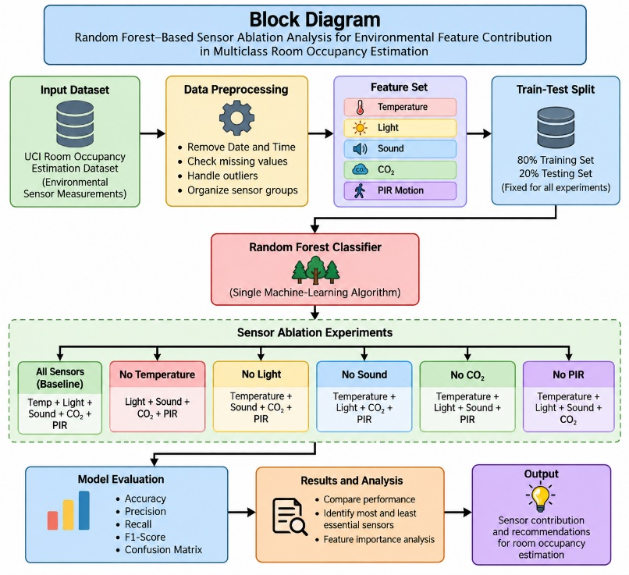

Flowchart
